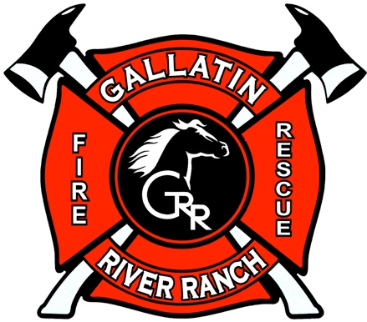

SAFETY TIPS FROM THE GRR FIRE DEPARTMENT
August 2022

The wildland fire season is in full swing. We’ve been lucky so far this summer while huge fires burn elsewhere, but luck has no role in wildland fire preparation or prevention.

Parched grasses and other fuels burn hot and fast, especially on hot, windy days. “Red Flag Days” are the most hazardous.

A Burn Ban was enacted on 7/19/22 and will likely remain in effect until the fall. This prohibits fires in the Picnic Area fire pit but does not prohibit continuously supervised fires in home outdoor fireplaces, screened fire pits, or chimeneas. Don’t use these on Red Flag days or in windy conditions. The fire must be doused with water until cold to touch when you are done. Never leave a fire unattended or let it “burn itself out” when you finish enjoying your fire. Fireworks and other pyrotechnics are prohibited during Burn Bans.

Other things you can do include: 1. avoid driving on back roads where un-mowed grass or weeds grow in the middle of the roadbed; 2. avoid parking along the sides of roads where vegetation might catch fire underneath your vehicle; 3. carry a 4-pound or larger fire extinguisher in each vehicle.

Consider getting a free Wildland Fire Risk Assessment from the GRR Fire Department. Contact Chief Sprow marlinsprow32@gmail.com, or email admin@grrfd.org to set up an appointment.

August is a good time for homeowners to walk their property with wildland fire risk reduction in mind. Check out the GRRFD website Getting Informed section for more information about wildland fire preparedness recommendations: http://www.grrrfd.org/get-informed/.

Construction on the new GRR Fire Station has begun!

Please visit the GRR Fire Department website to learn more: http://www.grrrfd.org/.

